 | Full (Ref)  N=7,019 | Marginal  N=1,136 | Low  N=1,218 | Very Low  N=721 | Overall  (N=10,094)
 | N (%) | N (%) | N (%) | N (%) | N (%)
Sex
Male | 3509 (50) | 533 (46.9) | 569 (51.5) | 569 (46.7) | 4,954 (49.1)
Female | 3,510 (50.0) | 603 (53.1) | 649 (53.3) | 378 (52.4) | 5,140 (50.9)
Age (years) | 49 (19) | 42 (18) | 42 (17) | 42 (16) | 47 (19)
Race/Ethnicity
NH White | 3,412 (48.6) | 345 (30.4) | 318 (26.1) | 250 (34.7) | 4,325 (42.8)
NH Black | 1,441 (20.5) | 297 (26.1) | 331 (27.2) | 194 (26.9) | 2,263 (22.4)
Mexican-American | 868 (12.4) | 267 (23.5) | 294 (24.1) | 139 (19.3) | 1,568 (15.5)
Other Hispanic | 520 (7.4) | 126 (11.1) | 165 (13.5) | 95 (13.2) | 906 (9.0)
Other, incl. Multi-Racial | 778 (11.1) | 101 (8.9) | 110 (9.0) | 43 (6.0) | 1,032 (10.3)
Highest Educational Attainment
Less than 9th Grade | 1,382 (19.7) | 396 (34.9) | 504 (41.4) | 284 (39.4) | 2,566 (25.4)
High School Graduate or Equivalent | 1,730 (24.6) | 320 (28.2) | 327 (26.8) | 197 (27.3) | 2,574 (25.5)
Some College | 1,939 (27.6) | 313 (27.6) | 303 (24.9) | 210 (29.1) | 2,756 (27.4)
College or Above | 1,968 (28.0) | 107 (9.4) | 84 (6.9) | 30 (4.2) | 2,189 (21.7)
Family Income: Poverty Ratio
Below Poverty | 993 (14.1) | 397 (34.9) | 528 (43.3) | 375 (52.0) | 2,293 (22.7)
Near/Working Class | 2,645 (37.7) | 583 (51.3) | 585 (48.0) | 315 (43.7) | 4,128 (40.9)
High Income | 3,381 (48.2) | 156 (13.7) | 105 (8.6) | 31 (4.3) | 3,673 (36.4)
Cycle Year
2005–2006 | 1,179 (16.8) | 154 (13.6) | 148 (12.2) | 70 (9.7) | 1,551 (15.4)
2007–2008 | 1,313 (18.7) | 175 (15.4) | 168 (13.8) | 93 (12.9) | 1,749 (17.3)
2009–2010 | 1,246 (17.8) | 197 (17.3) | 234 (19.2) | 148 (20.5) | 1,825 (18.1)
2011–2012 | 1,109 (15.8) | 195 (17.2) | 192 (15.8) | 127 (17.6) | 1,623 (16.1)
2013–2014 | 1,203 (17.1) | 199 (17.5) | 218 (17.9) | 138 (19.1) | 1,758 (17.4)
2015–2016 | 969 (13.8) | 216 (19.0) | 258 (21.2) | 145 (20.1) | 1,588 (15.7)

Table 1: Unweighted Demographic Characteristics of the Analytic Study Population
- Unweighted descriptive statistics count (frequency) and proportion (percentage) per food security category reported.

Study Population Descriptive Statistics
In the overall unweighted analytic sample (N=10,094), 50.9% of participants identified female and 49.1% identified as male (Table 1). The average age across the study population was 47 years. The mean age across food security categories besides the high food secure group (49) was 42 years. Non-Hispanic White adults represented majority of the population (42.8%), followed by Non-Hispanic Black (22.4%), Mexican American (15.5%), other Hispanic (9.0%), and individuals that identify with other racial identities or multi-racial (10.3%). For education levels, 25.4% of participants had an education less than 9th grade, 25.5% graduated from high school or an education equivalent, 27.4% attained some level of college, and 21.7% held a college degree or higher. For household income level, majority of participants were near or working class (40.9%), followed high income households (36.4%), and below poverty households (22.7%). The distribution varied by each NHANES cycle year, with 15.4% of participants from 2005–2006, 17.3% from 2007–2008, 18.1% from 2009–2010, 16.1% from 2011–2012, 17.4% from 2013–2014, and 15.7% from 2015–2016.
Table 2: Detection Frequency and Distribution of Urinary Phenol Concentrations (ng/mL)

Urinary Metabolite | Abbreviation | %>LOD | 25th | GM | 75th
Bisphenol A | BPA | 92% | 0.69 | 1.52 | 3.10
2-Hydroxy-4-metoxybenzophenone | Benzophenone-3 | 96% | 4.71 | 21.05 | 76.71
2,4,4’-Trichloro-2’-hydroxyphenyl ether | Triclosan | 75% | 1.80 | 12.22 | 49.40
Ethyl paraben | EPB | 50% | 0.71 | 2.51 | 6.70
Methyl paraben | MPB | 99% | 13.33 | 51.21 | 192.50
Propyl paraben | PPB | 95% | 1.11 | 6.72 | 40.90
- %>LOD represents the limit of detection of phenol metabolite concentrations. Values below the detection limit are imputed as LOD $\sqrt{2}$by NHANES. The 25th and 75th percentiles are log-transformed. GM represents the geometric mean.

Detection Frequency and Distribution
The detection frequencies of the urinary phenol metabolites were mostly above 90%, as the limit of detection had to be equivalent to or above 50%. The urinary metabolites below 90% were Triclosan (75%) and EPB (50%). The geometric means of the urinary metabolite concentrations (ng/mL) ranged from 1.52 to 51.21. Bisphenol A had a geometric mean of 1.52 ng/mL, Benzophenone-3 had a geometric mean of 21.05 ng/mL, Triclosan had a geometric mean of 12.22 ng/mL, Ethyl paraben had a geometric mean of 2.51 ng/mL, Methyl paraben had a geometric mean of 51.21 ng/mL, and Propyl paraben had a geometric mean of 6.72 ng/mL. The 25th and 75th percentile concentrations varied by metabolite, ranging from 0.69 to 13.33 ng/mL at the 25th percentile and from 3.10 to 192.50 ng/mL at the 75th percentile.

Table 3: Adjusted Linear Regression: Self-Reported Food Security Status and Urinary Phenol Metabolites

Phenol Metabolite | Food Security Level | % Difference | 95% LCI 95% UCI |  | P-Value
BPA | High (Ref)
 | Marginal | 1.80 | -5.91 | 10.15 | 0.65
 | Low | 7.53 | -1.27 | 17.12 | 0.09
 | Very Low | 7.61 | -4.48 | 21.23 | 0.22
BP3 | High (Ref)
 | Marginal | -19.82 | -31.68 | -5.91 | 0.01
 | Low | -17.40 | -29.05 | -3.84 | 0.01
 | Very Low | -19.55 | -35.27 | -0.02 | 0.05
TRS | High (Ref)
 | Marginal | -14.72 | -28.86 | 2.22 | 0.08
 | Low | -12.65 | -25.06 | 1.80 | 0.08
 | Very Low | -24.46 | -36.76 | -9.77 | 0.00
BUP | High (Ref)
 | Marginal | -14.08 | -21.33 | -6.15 | 0.00
 | Low | -12.94 | -23.29 | -1.18 | 0.03
 | Very Low | -25.49 | -34.95 | -14.66 | 0.00
$$EPB$$ | High (Ref)
 | Marginal | -10.97 | -21.90 | 1.50 | 0.08
 | Low | -5.65 | -17.98 | 8.53 | 0.41
 | Very Low | -25.96 | -35.07 | -15.57 | 0.00
$$MPB$$ | High (Ref)
 | Marginal | -16.65 | -26.78 | -5.10 | 0.01
 | Low | -14.81 | -28.35 | 1.29 | 0.07
 | Very Low | -21.53 | -35.05 | -5.18 | 0.01
$$PPB$$ | High (Ref)
 | Marginal | -16.26 | -28.75 | -1.59 | 0.03
 | Low | -15.16 | -32.01 | 5.85 | 0.14
 | Very Low | -25.08 | -40.79 | -5.20 | 0.02
- Values are adjusted percent differences in urinary phenol metabolite concentrations (ng/mL) compared to the High Food Secure category (reference group) based on multivariable linear regression models. adjusted for age, gender, education, cycle year, race/ethnicity, poverty: income ratio and creatinine.
- 95% LCI= 95% lower confidence interval; 95% UCI= 95% upper confidence interval.
- Abbreviations: BPA =Bisphenol A; BP3 =Bbenzophenone-3; TRS = 2,4,4’-Trichloro-2’-hydroxyphenyl ether; BUP = butyl paraben; EPB = ethyl paraben; MPB = methyl paraben; PPB = propyl paraben.

Adjusted Linear Regression Table
The adjusted percent differences in urinary phenol metabolite concentrations between the high food security reference group and the marginal, low, and very low food security groups are shown (Table 3). For BPA, percent differences ranged from 1.80% in the marginal group to 7.61% in the very low food security group, with 95% confidence intervals from –5.91% to 21.23%. For BP3, percent differences ranged from –17.40% to –19.82% in the marginal and low food security groups and –19.55% in the very low food security group, with confidence intervals from –35.27% to –3.84%. For Triclosan, percent differences ranged from –12.65% to –24.46% across food security categories, with confidence intervals from –36.76% to 2.22%. For butyl paraben (BUP), percent differences ranged from –14.08% in the marginal group to –25.49% in the very low food security group, with confidence intervals between –34.95% and –6.15%. For ethyl paraben (EPB), percent differences ranged from –10.97% to –25.96%, with confidence intervals from –35.07% to 8.53%. For methyl paraben (MPB), percent differences ranged from –14.81% to –21.53% across food security categories, with confidence intervals between –35.05% and 1.29%. For propyl paraben (PPB), percent differences ranged from –15.16% to –25.08%, with confidence intervals from –40.79% to 5.85%.

Figure 1: Household Food Security Associations with Urinary Phenol Concentrations
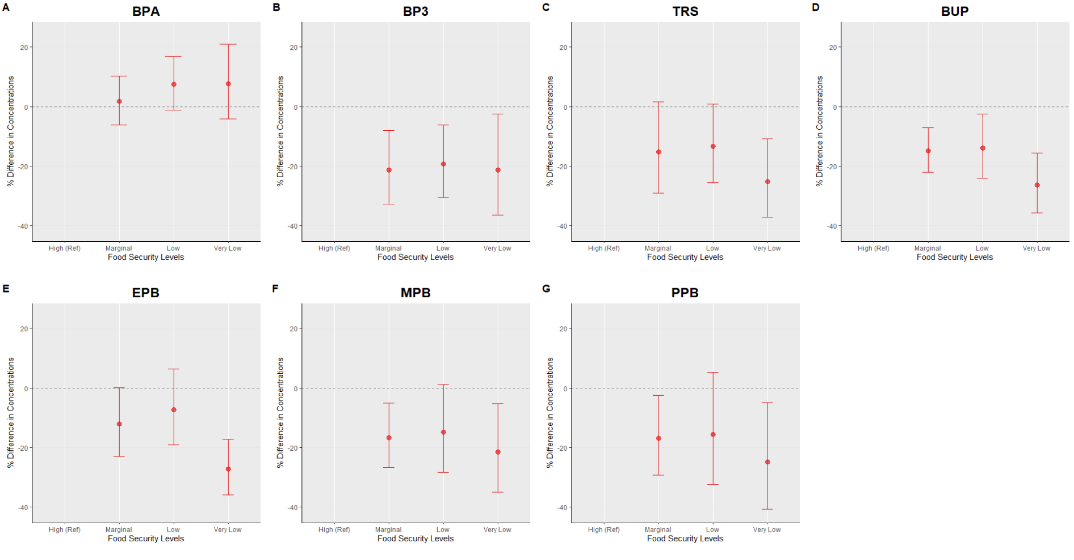
- Panels A–G represent adjusted percent differences in urinary phenol metabolite concentrations. Reference is High Food Secure. Circles represent estimated percent differences; bars represent 95% confidence intervals. All models are adjusted for age, sex education, race/ethnicity, poverty-income ratio, cycle year, and creatinine.

Multiple Linear Regression Models
One urinary phenol metabolite (BPA, BP3, TRS, EPB, MPB, and PPB) is shown in each panel, with the high food security group as the reference (Figure 1). The food security levels are shown on the x-axis and the percent differences in urinary phenol concentrations are found on the y-axis. Error bars represent 95% confidence intervals, as points reflect the estimated percent differences. Age, sex, education, race/ethnicity, cycle year, poverty-income ratio, and creatinine are all adjusted for in all models.

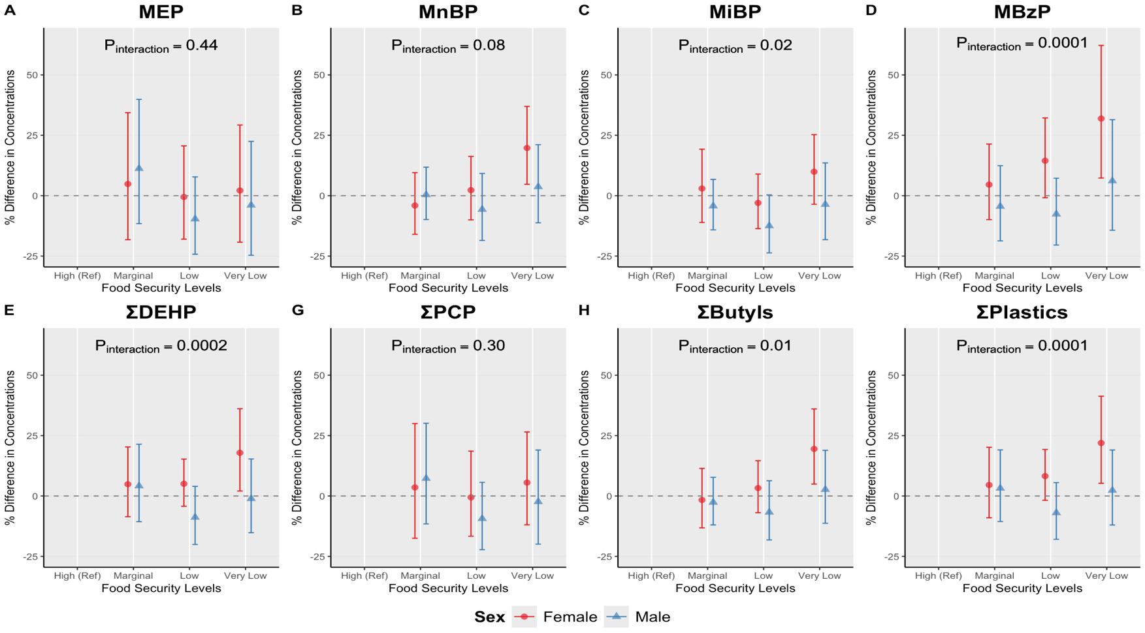
Figure 2: Strata Specific Adjusted Linear Regression Plot: Self-Reported Food Security Status and Urinary Phthalate Metabolites with Sex Interaction
- Sex stratified adjusted percent differences (95% confidence intervals) in urinary phthalate metabolite concentrations across food security levels, estmated from multivariable linear regression models adjusted for age, race and ethnicity, education, survey cycle, poverty:income ratio and creatinine. High Food Secure is the reference group.
- P_{interaction} values are reported from food security*sex interaction models, where food security is modeled as continuous variable.

Figure 3: Strata-Specific Adjusted Linear Regression Plot: Self-Reported Food Security Status and Urinary Phthalate Metabolites with Race and Ethnicity Interaction
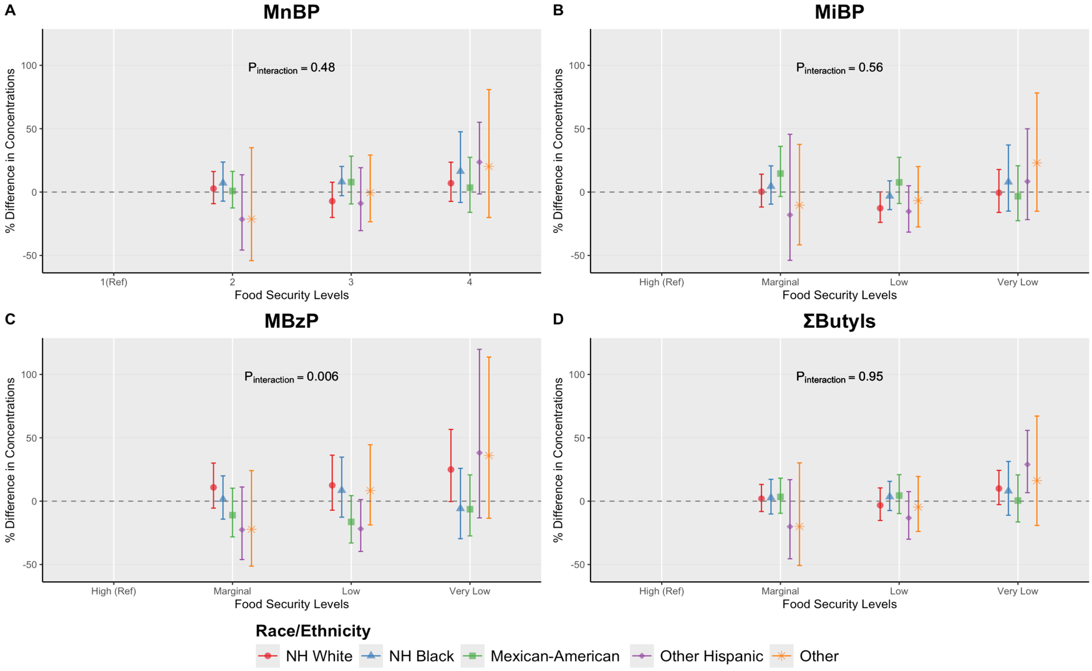
- Race stratified adjusted percent differences (95% confidence intervals) in urinary phthalate metabolite concentrations across food security levels, estmated from multivariable linear regression models adjusted for age, sex, education, survey cycle, poverty:income ratio and creatinine. High Food Secure is the reference group.
- P_{interaction} values are reported from food security*race and ethnicity interaction models, where food security is modeled as continuous variable.
- NH White: Non Hispanic White; NH Black: Non-Hispanic Black

Supplemental Figure 1: Flowchart for NHANES Analytic Sample (2001-2018)
XXX NHANES participants with available phthalates, food security and/or demographic data
Removed XXX pediatric participants and those without complete exposure & covariate data

XXX Adult participants with (n=8 phthalates measured across relevant cycle years 2001-2018)

Removed XXX participants with missing creatinine, or exposure data

XXX Adult participants with available creatinine and USDA FSSM questionnaire data

Removed XXX participants with missing urinary phthalate concentrations or those with concentrations 5 SDs above the mean

10,094 included in final analytic cohort (complete cases)

- Adult participants from NHANES cycles 2001-2018 were included base don available demographic, food security, urinary phthalate and creatinine data. Exclusions were applied for missing exposure values, missing urinary creatinine and missing urinary phthalate concentrations as well as extreme outliers.
- Abbreviations: NHANES, National Health and Nutrition Examination Survey; FSSM, Food Security Survey Module; SD, standard deviation

Supplemental Figure 2: Spearman Correlation Matrix for Log Urinary Phthalate Metabolites

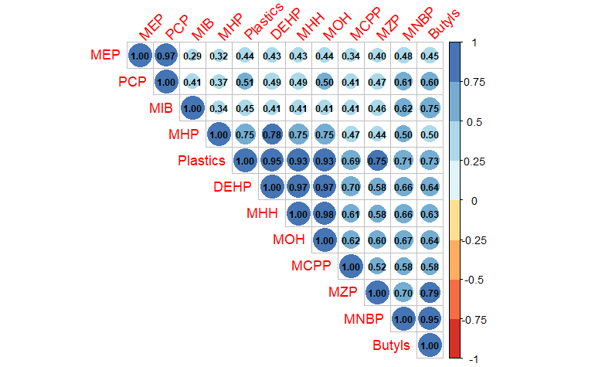

- Spearman correlation coefficients are visualized, with larger and darker circles indicating stronger positive correlations between analytes. All correlations shown are positive, suggesting co-occurrence or shared sources among the measured phthalate metabolites and related compounds.

Supplemental Figure 3: Strata-Specific Adjusted Linear Regression Plot: Self-Reported Food Security Status and Urinary Phthalate Metabolites with Race and Ethnicity Interaction
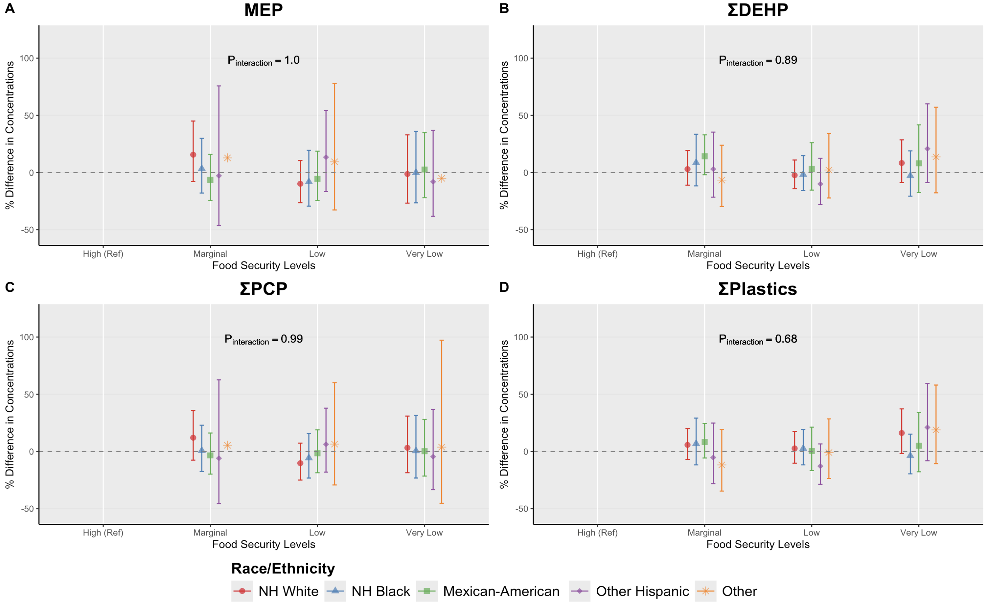
- Race stratified adjusted percent differences (95% confidence intervals) in urinary phthalate metabolite concentrations across food security levels, estmated from multivariable linear regression models adjusted for age, sex, education, survey cycle, poverty:income ratio and creatinine. High Food Secure is the reference group.
- P_{interaction} values are reported from food security*race and ethnicity interaction models, where food security is modeled as continuous variable.
- NH White: Non Hispanic White; NH Black: Non-Hispanic Black

Supplemental Table 1: Creatinine Adjusted: Self-Reported Food Security Status
O  Phenol Metabolite del | Term | Food Security Level | % Difference | 95% CI |  | P-Value
BPA | Intercept (Ref)  Marginal Food Secure  Low Food Secure  Very Low Food Secure | 1
BPA |  | 2 | 1.36 | -11.93 | 16.66 | 0.85
BPA |  | 3 | -9.85 | -19.51 | 0.97 | 0.07
BPA |  | 4 | -7.25 | -20.00 | 7.53 | 0.32
BP3 | Intercept (Ref)  Marginal Food Secure  Low Food Secure  Very Low Food Secure | 1
BP3 |  | 2 | -5.08 | -12.02 | 2.41 | 0.18
BP3 |  | 3 | -2.70 | -9.25 | 4.32 | 0.44
BP3 |  | 4 | 10.42 | -0.79 | 22.89 | 0.07
TRS | Intercept (Ref)  Marginal Food Secure  Low Food Secure  Very Low Food Secure | 1
TRS |  | 2 | 23.17 | 10.38 | 37.43 | 0.00
TRS |  | 3 | 18.18 | 7.75 | 29.61 | 0.00
TRS |  | 4 | 27.84 | 15.56 | 41.41 | 0.00
BUP | Intercept (Ref)  Marginal Food Secure  Low Food Secure  Very Low Food Secure | 1
BUP |  | 2 | 6.28 | -2.30 | 15.60 | 0.15
BUP |  | 3 | 11.59 | 0.93 | 23.38 | 0.03
BUP |  | 4 | 33.66 | 14.57 | 55.92 | 0.00
EPB | Intercept (Ref)  Marginal Food Secure  Low Food Secure  Very Low Food Secure | 1
EPB |  | 2 | -9.56 | -16.70 | -1.82 | 0.02
EPB |  | 3 | -17.65 | -24.29 | -10.43 | 0.00
EPB |  | 4 | -9.17 | -19.26 | 2.18 | 0.11
MPB | Intercept (Ref)  Marginal Food Secure  Low Food Secure  Very Low Food Secure | 1
MPB |  | 2 | 1.61 | -10.47 | 15.31 | 0.80
MPB |  | 3 | -6.53 | -15.22 | 3.05 | 0.17
MPB |  | 4 | -1.07 | -12.16 | 11.42 | 0.86
PPB | Intercept (Ref)  Marginal Food Secure  Low Food Secure | 1
PPB |  | 2 | 2.86 | -3.72 | 9.89 | 0.40
PPB |  | 3 | 6.08 | 0.09 | 12.43 | 0.05
PPB |  |  | 20.60 | 9.99 | 32.23 | 0.00
PPB | Very Low Food Secure | 4
- Values are unadjusted percent differences in urinary phthalate metabolite concentrations (ng/mL) compared to the reference group (High (Ref)y Food Secure) based on multivariable linear regression models.
- 95% CI= 95% confidence interval.

Supplemental Table 2: Strata Specific Adjusted Linear Regression Full Table: Self-Reported Food Security Status and Urinary Phthalate Metabolites with Sex Interaction
Sex | Phthalate Metabolite | Food Security Level | % Difference (Interaction) | 95% CI |  | P-Value
Female | MEP | High (Ref)
 |  | Marginal | 4.84 | -18.22 | 34.39 | 0.96
 |  | Low | -0.55 | -17.99 | 20.61 | 1.00
 |  | Very Low | 2.15 | -19.27 | 29.25 | 1.00
Male |  | High (Ref)
 |  | Marginal | 11.23 | -11.56 | 39.88 | 0.62
 |  | Low | -9.63 | -24.23 | 7.79 | 0.44
 |  | Very Low | -3.93 | -24.65 | 22.49 | 0.97
Female | MnBP | High (Ref)
 |  | Marginal | -4.07 | -16.00 | 9.56 | 0.85
 |  | Low | 2.29 | -9.99 | 16.25 | 0.97
 |  | Very Low | 19.75 | 4.70 | 36.96 | 0.00
Male |  | High (Ref)
 |  | Marginal | 0.39 | -9.86 | 11.80 | 1.00
 |  | Low | -5.68 | -18.53 | 9.20 | 0.73
 |  | Very Low | 3.69 | -11.23 | 21.11 | 0.93
Female | MiBP | High (Ref)
 |  | Marginal | 2.97 | -11.09 | 19.26 | 0.95
 |  | Low | -2.99 | -13.63 | 8.97 | 0.90
 |  | Very Low | 9.92 | -3.56 | 25.28 | 0.24
Male |  | High (Ref)
 |  | Marginal | -4.26 | -14.14 | 6.75 | 0.72
 |  | Low | -12.50 | -23.69 | 0.32 | 0.06
 |  | Very Low | -3.62 | -18.20 | 13.57 | 0.94
Female | MBzP | High (Ref)
 |  | Marginal | 4.58 | -9.90 | 21.38 | 0.86
 |  | Low | 14.48 | -0.85 | 32.18 | 0.07
 |  | Very Low | 31.93 | 7.31 | 62.21 | 0.00
Male |  | High (Ref)
 |  | Marginal | -4.41 | -18.71 | 12.42 | 0.89
 |  | Low | -7.62 | -20.42 | 7.23 | 0.51
 |  | Very Low | 6.13 | -14.31 | 31.46 | 0.89
Female | $∑$DEHP | High (Ref)
 |  | Marginal | 4.88 | -8.57 | 20.30 | 0.80
 |  | Low | 5.06 | -4.25 | 15.28 | 0.51
 |  | Very Low | 17.87 | 2.06 | 36.12 | 0.02
Male |  | High (Ref)
 |  | Marginal | 4.17 | -10.63 | 21.42 | 0.90
 |  | Low | -8.83 | -20.08 | 3.99 | 0.26
 |  | Very Low | -1.10 | -15.20 | 15.33 | 1.00
Female | $$∑ PCP$$ | High (Ref)
 |  | Marginal | 3.55 | -17.50 | 29.97 | 0.98
 |  | Low | -0.58 | -16.65 | 18.59 | 1.00
 |  | Very Low | 5.55 | -11.94 | 26.52 | 0.86
Male |  | High (Ref)
 |  | Marginal | 7.27 | -11.56 | 30.10 | 0.78
 |  | Low | -9.36 | -22.23 | 5.65 | 0.34
 |  | Very Low | -2.38 | -19.94 | 19.03 | 0.99
Female | $$∑Butyls$$ | High (Ref)
 |  | Marginal | -1.65 | -13.19 | 11.42 | 0.99
 |  | Low | 3.28 | -6.92 | 14.60 | 0.85
 |  | Very Low | 19.48 | 4.93 | 36.05 | 0.00
Male |  | High (Ref)
 |  | Marginal | -2.61 | -11.97 | 7.74 | 0.90
 |  | Low | -6.74 | -18.19 | 6.32 | 0.51
 |  | Very Low | 2.70 | -11.29 | 18.90 | 0.96
Female | $$∑Plastics$$ | High (Ref)
 |  | Marginal | 4.55 | -9.03 | 20.16 | 0.84
 |  | Low | 8.22 | -1.78 | 19.25 | 0.15
 |  | Very Low | 21.95 | 5.24 | 41.30 | 0.00
Male |  | High (Ref)
 |  | Marginal | 3.20 | -10.57 | 19.08 | 0.94
 |  | Low | -6.94 | -17.94 | 5.53 | 0.45
 |  | Very Low | 2.34 | -12.01 | 19.04 | 0.98
- Values represent percent differences for Food Security Level × Sex interaction terms, showing strata-specific estimates. Within each sex group (female, male), estimates indicate the percent difference for each food security level compared with the reference. Estimates are derived from multivariable linear regression models adjusted for age, race and ethnicity, education, cycle year, poverty:income ratio and creatinine.
- 95% CI = 95% confidence interval

Supplemental Table 3: Strata Specific Adjusted Linear Regression Full Table: Self-Reported Food Security Status and Urinary Mono-ethyl Phthalate Metabolites with Race and Ethnicity Interaction

Race/Ethnicity Category | Model | Food Security Contrast | % Difference | % Lower | % Upper | P-Value
NH White | MEP | High (Ref)
 |  | Marginal | 15.58 | -7.88 | 45.03 | 0.35
 |  | Low | -9.83 | -26.39 | 10.45 | 0.54
 |  | Very Low | -1.30 | -26.73 | 32.96 | 1.00
NH Black |  | High (Ref)
 |  | Marginal | 3.29 | -17.90 | 29.94 | 0.98
 |  | Low | -8.18 | -29.40 | 19.41 | 0.83
 |  | Very Low | -0.04 | -26.52 | 35.98 | 1.00
Mexican-American |  | High (Ref)
 |  | Marginal | -6.39 | -24.39 | 15.88 | 0.85
 |  | Low | -5.48 | -24.69 | 18.63 | 0.92
 |  | Very Low | 2.59 | -22.01 | 34.94 | 0.99
Other Hispanic |  | High (Ref)
 |  | Marginal | -2.83 | -46.27 | 75.74 | 1.00
 |  | Low | 13.42 | -16.60 | 54.26 | 0.71
 |  | Very Low | -8.08 | -38.24 | 36.83 | 0.95
Other |  | High (Ref)
 |  | Marginal | 12.80 | -58.55 | 206.98 | 0.99
 |  | Low | 9.36 | -32.75 | 77.85 | 0.96
 |  | Very Low | -5.06 | -65.26 | 159.47 | 1.00
- Values represent percent differences for Food Security Level × Race and Ethnicity interaction terms, showing strata-specific estimates. Within each race and ethnicity group (NH White, NH Black, Mexican American, Other Hispanic, Other, ) estimates indicate the percent difference for each food security level compared with the reference. Estimates are derived from multivariable linear regression models adjusted for age, sex, education, cycle year, poverty:income ratio and creatinine.
- NH White: Non Hispanic White; NH Black: Non-Hispanic Black
- 95% CI = 95% confidence interval

Supplemental Table 4: Strata Specific Adjusted Linear Regression Full Table: Self-Reported Food Security Status and Urinary Mono-n-butyl Phthalate Metabolites with Race and Ethnicity Interaction

Race/Ethnicity Category | Model | Food Security Contrast | % Difference | % Lower | % Upper | P-Value
NH White | MnBP | High (Ref)
 |  | Marginal | 2.76 | -9.15 | 16.22 | 0.94
 |  | Low | -7.17 | -20.03 | 7.75 | 0.56
 |  | Very Low | 7.00 | -7.36 | 23.59 | 0.61
NH Black |  | High (Ref)
 |  | Marginal | 7.15 | -7.17 | 23.67 | 0.59
 |  | Low | 8.09 | -2.84 | 20.25 | 0.23
 |  | Very Low | 16.41 | -8.18 | 47.58 | 0.34
Mexican-American |  | High (Ref)
 |  | Marginal | 0.87 | -12.53 | 16.31 | 1.00
 |  | Low | 7.86 | -9.35 | 28.34 | 0.67
 |  | Very Low | 3.47 | -15.98 | 27.43 | 0.97
Other Hispanic |  | High (Ref)
 |  | Marginal | -21.47 | -45.73 | 13.66 | 0.33
 |  | Low | -8.92 | -30.42 | 19.24 | 0.80
 |  | Very Low | 23.63 | -1.45 | 55.10 | 0.08
Other |  | High (Ref)
 |  | Marginal | -21.25 | -54.08 | 35.03 | 0.65
 |  | Low | -0.54 | -23.44 | 29.22 | 1.00
 |  | Very Low | 20.24 | -20.07 | 80.88 | 0.64
- Values represent percent differences for Food Security Level × Race and Ethnicity interaction terms, showing strata-specific estimates. Within each race and ethnicity group (NH White, NH Black, Mexican American, Other Hispanic, Other, ) estimates indicate the percent difference for each food security level compared with the reference. Estimates are derived from multivariable linear regression models adjusted for age, sex, education, cycle year, poverty:income ratio and creatinine.
- NH White: Non Hispanic White; NH Black: Non-Hispanic Black
- 95% CI = 95% confidence interval

Supplemental Table 5: Strata Specific Adjusted Linear Regression Full Table: Self-Reported Food Security Status and Urinary Mono-isobutyl Phthalate Metabolites with Race and Ethnicity Interaction

Race/Ethnicity Category | Model | Food Security Contrast | % Difference | % Lower | % Upper | P-Value
NH White | MiBP | High (Ref)
 |  | Marginal | 0.33 | -11.81 | 14.13 | 1.00
 |  | Low | -12.73 | -23.93 | 0.12 | 0.05
 |  | Very Low | -0.54 | -16.04 | 17.82 | 1.00
NH Black |  | High (Ref)
 |  | Marginal | 4.52 | -9.50 | 20.71 | 0.85
 |  | Low | -3.16 | -13.85 | 8.85 | 0.89
 |  | Very Low | 7.94 | -15.03 | 37.13 | 0.84
Mexican-American |  | High (Ref)
 |  | Marginal | 14.62 | -3.46 | 36.08 | 0.17
 |  | Low | 7.69 | -8.99 | 27.42 | 0.66
 |  | Very Low | -3.32 | -22.60 | 20.77 | 0.98
Other Hispanic |  | High (Ref)
 |  | Marginal | -18.03 | -53.85 | 45.60 | 0.80
 |  | Low | -15.26 | -31.61 | 5.00 | 0.19
 |  | Very Low | 8.34 | -21.72 | 49.93 | 0.92
Other |  | High (Ref)
 |  | Marginal | -10.37 | -41.63 | 37.62 | 0.91
 |  | Low | -6.66 | -27.49 | 20.15 | 0.89
 |  | Very Low | 23.00 | -15.10 | 78.20 | 0.47
- Values represent percent differences for Food Security Level × Race and Ethnicity interaction terms, showing strata-specific estimates. Within each race and ethnicity group (NH White, NH Black, Mexican American, Other Hispanic, Other, ) estimates indicate the percent difference for each food security level compared with the reference. Estimates are derived from multivariable linear regression models adjusted for age, sex, education, cycle year, poverty:income ratio and creatinine.
- NH White: Non Hispanic White; NH Black: Non-Hispanic Black
- 95% CI = 95% confidence interval

Supplemental Table 6: Strata Specific Adjusted Linear Regression Full Table: Self-Reported Food Security Status and Urinary Mono-benzyl Phthalate Metabolites with Race and Ethnicity Interaction

Race/Ethnicity Category | Model | Food Security Contrast | % Difference | % Lower | % Upper | P-Value
NH White | MBzP | High (Ref)
 |  | Marginal | 10.86 | -5.50 | 30.06 | 0.34
 |  | Low | 12.50 | -7.11 | 36.26 | 0.38
 |  | Very Low | 24.95 | -0.30 | 56.61 | 0.05
NH Black |  | High (Ref)
 |  | Marginal | 1.46 | -14.20 | 19.97 | 1.00
 |  | Low | 8.50 | -12.63 | 34.73 | 0.76
 |  | Very Low | -5.87 | -29.61 | 25.88 | 0.95
Mexican-American |  | High (Ref)
 |  | Marginal | -11.04 | -28.20 | 10.22 | 0.49
 |  | Low | -16.38 | -33.00 | 4.35 | 0.16
 |  | Very Low | -6.38 | -27.41 | 20.76 | 0.91
Other Hispanic |  | High (Ref)
 |  | Marginal | -22.59 | -46.10 | 11.17 | 0.26
 |  | Low | -21.85 | -39.67 | 1.24 | 0.07
 |  | Very Low | 38.14 | -13.19 | 119.81 | 0.27
Other |  | High (Ref)
 |  | Marginal | -22.23 | -51.27 | 24.10 | 0.50
 |  | Low | 8.36 | -18.74 | 44.51 | 0.89
 |  | Very Low | 35.97 | -13.49 | 113.71 | 0.29
- Values represent percent differences for Food Security Level × Race and Ethnicity interaction terms, showing strata-specific estimates. Within each race and ethnicity group (NH White, NH Black, Mexican American, Other Hispanic, Other, ) estimates indicate the percent difference for each food security level compared with the reference. Estimates are derived from multivariable linear regression models adjusted for age, sex, education, cycle year, poverty:income ratio and creatinine.
- NH White: Non Hispanic White; NH Black: Non-Hispanic Black
- 95% CI = 95% confidence interval

Supplemental Table 7: Strata Specific Adjusted Linear Regression Full Table: Self-Reported Food Security Status and Urinary $∑$Di-2-ethylhexyl Phthalate Metabolites with Race and Ethnicity Interaction

Race/Ethnicity Category | Model | Food Security Contrast | % Difference | % Lower | % Upper | P-Value
NH White | $∑$DEHP | High (Ref)
 |  | Marginal | 2.98 | -11.08 | 19.27 | 0.95
 |  | Low | -2.36 | -14.08 | 10.96 | 0.96
 |  | Very Low | 8.33 | -8.73 | 28.58 | 0.62
NH Black |  | High (Ref)
 |  | Marginal | 8.59 | -11.66 | 33.47 | 0.72
 |  | Low | -1.71 | -15.75 | 14.67 | 0.99
 |  | Very Low | -2.89 | -20.70 | 18.93 | 0.98
Mexican-American |  | High (Ref)
 |  | Marginal | 14.20 | -1.92 | 32.97 | 0.11
 |  | Low | 3.26 | -15.41 | 26.06 | 0.97
 |  | Very Low | 8.08 | -17.53 | 41.64 | 0.88
Other Hispanic |  | High (Ref)
 |  | Marginal | 3.01 | -21.58 | 35.32 | 0.99
 |  | Low | -10.00 | -27.94 | 12.40 | 0.60
 |  | Very Low | 20.83 | -8.78 | 60.06 | 0.30
Other |  | High (Ref)
 |  | Marginal | -6.66 | -29.67 | 23.87 | 0.92
 |  | Low | 2.18 | -22.24 | 34.27 | 1.00
 |  | Very Low | 13.68 | -17.76 | 57.14 | 0.73
- Values represent percent differences for Food Security Level × Race and Ethnicity interaction terms, showing strata-specific estimates. Within each race and ethnicity group (NH White, NH Black, Mexican American, Other Hispanic, Other, ) estimates indicate the percent difference for each food security level compared with the reference. Estimates are derived from multivariable linear regression models adjusted for age, sex, education, cycle year, poverty:income ratio and creatinine.
- NH White: Non Hispanic White; NH Black: Non-Hispanic Black
- 95% CI = 95% confidence interval

Supplemental Table 8: Strata Specific Adjusted Linear Regression Full Table: Self-Reported Food Security Status and Urinary $∑$Personal Care Product Associated Phthalate Metabolites with Race and Ethnicity Interaction

Race/Ethnicity Category | Model | Food Security Contrast | % Difference | % Lower | % Upper | P-Value
NH White | $$∑PCP$$ | High (Ref)
 |  | Marginal | 12.01 | -7.58 | 35.75 | 0.42
 |  | Low | -10.27 | -24.96 | 7.31 | 0.39
 |  | Very Low | 3.22 | -18.61 | 30.90 | 0.99
NH Black |  | High (Ref)
 |  | Marginal | 0.72 | -17.49 | 22.95 | 1.00
 |  | Low | -5.74 | -23.24 | 15.76 | 0.88
 |  | Very Low | 0.53 | -23.21 | 31.61 | 1.00
Mexican-American |  | High (Ref)
 |  | Marginal | -3.49 | -19.82 | 16.15 | 0.96
 |  | Low | -1.64 | -18.64 | 18.92 | 1.00
 |  | Very Low | 0.20 | -21.55 | 27.98 | 1.00
Other Hispanic |  | High (Ref)
 |  | Marginal | -5.94 | -45.60 | 62.64 | 0.99
 |  | Low | 6.27 | -18.08 | 37.84 | 0.93
 |  | Very Low | -4.59 | -33.40 | 36.68 | 0.99
Other |  | High (Ref)
 |  | Marginal | 5.43 | -59.41 | 173.84 | 1.00
 |  | Low | 6.42 | -29.28 | 60.14 | 0.98
 |  | Very Low | 3.76 | -45.42 | 97.25 | 1.00
- Values represent percent differences for Food Security Level × Race and Ethnicity interaction terms, showing strata-specific estimates. Within each race and ethnicity group (NH White, NH Black, Mexican American, Other Hispanic, Other, ) estimates indicate the percent difference for each food security level compared with the reference. Estimates are derived from multivariable linear regression models adjusted for age, sex, education, cycle year, poverty:income ratio and creatinine.
- NH White: Non Hispanic White; NH Black: Non-Hispanic Black
- 95% CI = 95% confidence interval

Supplemental Table 9: Strata Specific Adjusted Linear Regression Full Table: Self-Reported Food Security Status and Urinary $∑$Butyl Associated Phthalate Metabolites with Race and Ethnicity Interaction

Race/Ethnicity Category | Model | Food Security Contrast | % Difference | % Lower | % Upper | P-Value
NH White | $$∑Butyls$$ | High (Ref)
 |  | Marginal | 1.96 | -8.16 | 13.19 | 0.96
 |  | Low | -3.25 | -15.25 | 10.44 | 0.91
 |  | Very Low | 9.96 | -2.72 | 24.30 | 0.19
NH Black |  | High (Ref)
 |  | Marginal | 2.64 | -10.14 | 17.23 | 0.96
 |  | Low | 3.49 | -7.40 | 15.65 | 0.85
 |  | Very Low | 8.04 | -11.12 | 31.32 | 0.73
Mexican-American |  | High (Ref)
 |  | Marginal | 3.35 | -9.57 | 18.12 | 0.92
 |  | Low | 4.44 | -9.81 | 20.93 | 0.87
 |  | Very Low | 0.48 | -16.40 | 20.77 | 1.00
Other Hispanic |  | High (Ref)
 |  | Marginal | -20.13 | -45.46 | 16.95 | 0.42
 |  | Low | -13.26 | -30.04 | 7.54 | 0.31
 |  | Very Low | 28.96 | 6.70 | 55.85 | 0.00
Other |  | High (Ref)
 |  | Marginal | -19.93 | -50.76 | 30.21 | 0.63
 |  | Low | -4.65 | -23.90 | 19.47 | 0.95
 |  | Very Low | 16.23 | -19.19 | 67.16 | 0.70
- Values represent percent differences for Food Security Level × Race and Ethnicity interaction terms, showing strata-specific estimates. Within each race and ethnicity group (NH White, NH Black, Mexican American, Other Hispanic, Other, ) estimates indicate the percent difference for each food security level compared with the reference. Estimates are derived from multivariable linear regression models adjusted for age, sex, education, cycle year, poverty:income ratio and creatinine.
- NH White: Non Hispanic White; NH Black: Non-Hispanic Black
- 95% CI = 95% confidence interval; SE = standard error.

Supplemental Table 10: Strata Specific Adjusted Linear Regression Full Table: Self-Reported Food Security Status and Urinary $∑$Plastic Associated Phthalate Metabolites with Race and Ethnicity Interaction
Race/Ethnicity Category | Model | Food Security Contrast | % Difference | % Lower | % Upper | P-Value
NH White | $$∑Plastics$$ | High (Ref)
 |  | Marginal | 5.75 | -6.85 | 20.07 | 0.66
 |  | Low | 2.65 | -10.29 | 17.46 | 0.96
 |  | Very Low | 16.13 | -1.74 | 37.25 | 0.10
NH Black |  | High (Ref)
 |  | Marginal | 6.77 | -11.74 | 29.17 | 0.81
 |  | Low | 2.56 | -11.72 | 19.16 | 0.97
 |  | Very Low | -3.78 | -19.60 | 15.14 | 0.94
Mexican-American |  | High (Ref)
 |  | Marginal | 8.30 | -5.73 | 24.42 | 0.44
 |  | Low | 0.48 | -16.71 | 21.23 | 1.00
 |  | Very Low | 5.00 | -17.78 | 34.09 | 0.95
Other Hispanic |  | High (Ref)
 |  | Marginal | -5.30 | -28.14 | 24.81 | 0.96
 |  | Low | -12.86 | -28.74 | 6.57 | 0.29
 |  | Very Low | 21.02 | -8.12 | 59.41 | 0.28
Other |  | High (Ref)
 |  | Marginal | -11.78 | -34.67 | 19.14 | 0.70
 |  | Low | -0.97 | -23.65 | 28.45 | 1.00
 |  | Very Low | 18.84 | -10.66 | 58.08 | 0.39
- Values represent percent differences for Food Security Level × Race and Ethnicity interaction terms, showing strata-specific estimates. Within each race and ethnicity group (NH White, NH Black, Mexican American, Other Hispanic, Other, ) estimates indicate the percent difference for each food security level compared with the reference. Estimates are derived from multivariable linear regression models adjusted for age, sex, education, cycle year, poverty:income ratio and creatinine.
- NH White: Non Hispanic White; NH Black: Non-Hispanic Black
- 95% CI = 95% confidence interval

Supplemental Table 11: Unadjusted Linear Regression: Self-Reported Fasting Status and Urinary Phthalate Metabolites

Outcome | % Difference | % Lower | % Higher | P-value
MEP | 1.66 | 1.12 | 2.21 | 0.00
MBzP | 1.08 | 0.19 | 1.98 | 0.00
MiBP | -2.79 | -3.15 | -2.43 | 0.00
MnBP | 0.15 | -0.48 | 0.78 | 0.58
∑DEHP | -0.22 | -0.71 | 0.27 | 0.38
∑PCP | 1.10 | 0.63 | 1.57 | 0.00
∑Butyls | -0.20 | -0.64 | 0.24 | 0.37
∑Plastics | 0.09 | -0.38 | 0.56 | 0.71
- Values are differences in log-transformed urinary phthalate metabolite concentrations (ng/mL) between oral contraceptive users based on survey-weighted t-test estimates
- 95% CI = 95% confidence interval

Supplemental Table 12: Adjusted Linear Regression: Self-Reported Food Security Status and Urinary Phthalate Metabolites Fasting Status Interaction

Outcome | % Difference | % Lower | % Higher | P-value
MEP | 0.11 | -0.53 | 0.76 | 0.68
MnBP | -0.20 | -0.73 | 0.32 | 0.46
MiBP | 0.01 | -0.41 | 0.42 | 0.96
MBzP | -0.03 | -0.54 | 0.49 | 0.90
∑DEHP | -0.26 | -0.67 | 0.15 | 0.23
∑PCP | 0.05 | -0.48 | 0.58 | 0.84
∑Butyls | -0.09 | -0.46 | 0.28 | 0.70
∑Plastics | -0.10 | -0.55 | 0.35 | 0.67
- Values are differences in log-transformed urinary phthalate metabolite concentrations (ng/mL) between oral contraceptive users based on survey-weighted t-test estimates
- 95% CI = 95% confidence interval

Supplemental Table 13: Differences in Log-Transformed Urinary Phthalate Metabolites by Supplement Use: Survey-Weighted T-Test Estimates

Metabolite | Difference in Mean (log) | 95% CI | P-value
MBzP | 0.24 | [-0.10, 0.57] | 0.16
MiBP | -0.01 | [-0.40, 0.38] | 0.95
MnBP | -0.01 | [-0.40, 0.37] | 0.95
- Values are differences in log-transformed urinary phthalate metabolite concentrations (ng/mL) between supplement users based on survey-weighted t-test estimates.
- 95% CI = 95% confidence interval

Supplemental Table 14: Differences in Log-Transformed Urinary Phthalate Metabolites by Oral Contraceptive Use: Survey-Weighted T-Test Estimates

Metabolite | Difference in Mean (log) | 95% CI | P-value
MBzP | -0.18 | [-0.40, 0.04] | 0.11
MiBP | -0.08 | [-0.34, 0.28] | 0.54
MnBP | -0.20 | [-0.40, 0.01] | 0.04
- Values are differences in log-transformed urinary phthalate metabolite concentrations (ng/mL) between oral contraceptive users based on survey-weighted t-test estimates
- 95% CI = 95% confidence interval

